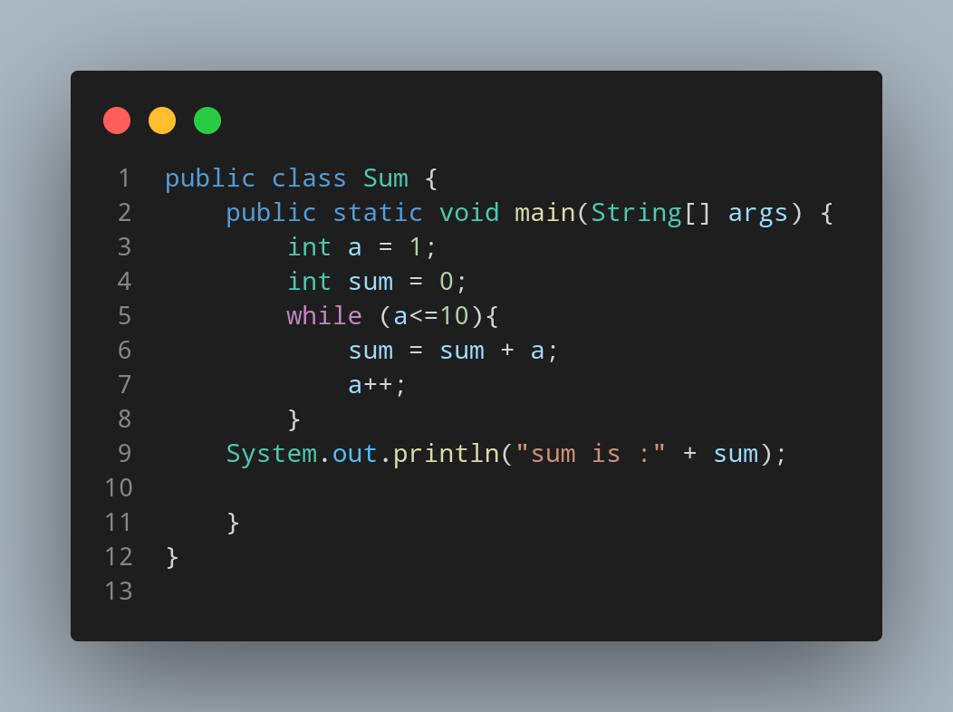

#Doc

File name Sum is created so we create a class name Sum, inside the class we created a main function.Inside main function we created two variable, a and sum both having integer data type. First we assigned a=1 and sum=0 as a defult value.Using while loop until a is greater that 10 , we looped our addition program (where add variable and a are added with each other and stored in same add variable). In each loop we increased our value of a by 1.

Lets see how this program work →

a = 1
add = 0

a can’t be more than 10 .. so loop starts

now add = 0 + 1 = 1

a++ now a = 2

repeat the loop

now add = 1 + 2

a++ now a = 3 and add = 3

repeat the loop until a = 10 then the condition dosn’t meet and loop ends.

Finally we print out our total data stored inside add.

